FOR SALE: MERCEDES VIANO (DIESEL)

Reserve Price: €10,000 (Bids welcome)
Make: Mercedes Viano
Description: Mercedes Viano (Variante: D2.2; Carburant: Gasoil)
Model/Year: 2014
Kilometres: 157810 km
Colour: Black
Interior:
- Semi Leather interior (Black)
- Automatic transmission
- Air conditioner
- Radio/CD Changer
- Electric windows
- Power Steering
- 8-seater including the driver

PLEASE TAKE NOTE OF THE FOLLOWING:

- Take note, that the car will be sold ‘As is’
- A valid control technique report is available for this car.

PROCEDURE TO BE FOLLOWED IF YOU ARE INTERESTED:

FILL IN YOUR DETAILS BELOW:

- SURNAME:………………………………………………………………………………………………..

- NAME:………………………………………………………………………………………………………

- IDENTITY NUMBER:………………………………………………………………………………………………….

- PHYSICAL ADDRESS………………………………………………………………………………………………….

- EMAIL ADDRESS…………………………………………………………………………………………

- PHONE NUMBER:…………………………………………………………………………………………

- BID/OFFER PRICE: €………………………………………………………………………

- SIGNATURE:………………………………………………………………………………………………..

VIEWING OF THE CAR: To arrange for viewing, please contact Ms Lilian Nabora at +32 273 520 70. The address is as follows:

Botswana Embassy
Avenue de Tervuren 169,
1150 Brussels

PLEASE SEND THE COMPLETED DOCUMENT TO THE ABOVE ADDRESS OR EMAIL TO boteur@gov.bw by 14th March 2025.

HERE ARE THE PHOTOS OF THE CAR:

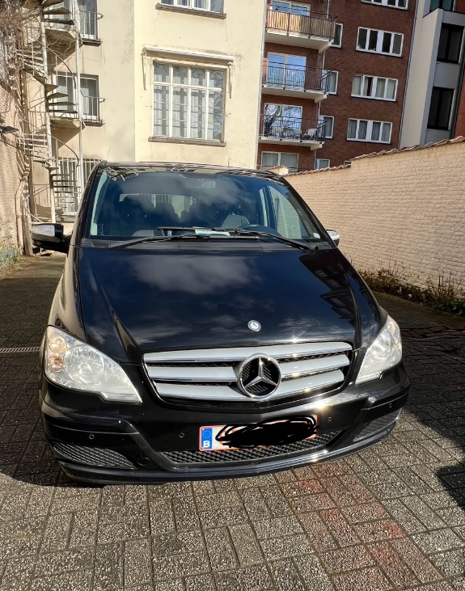 | 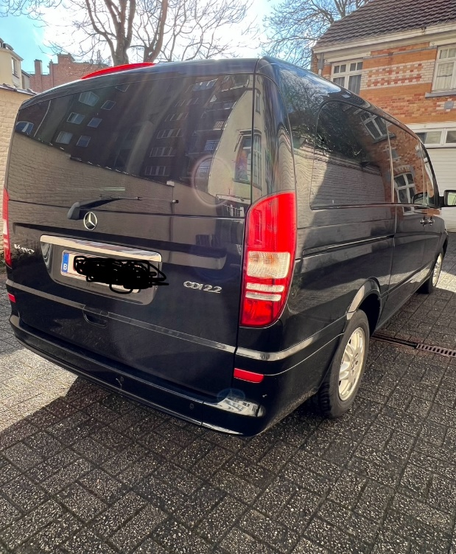
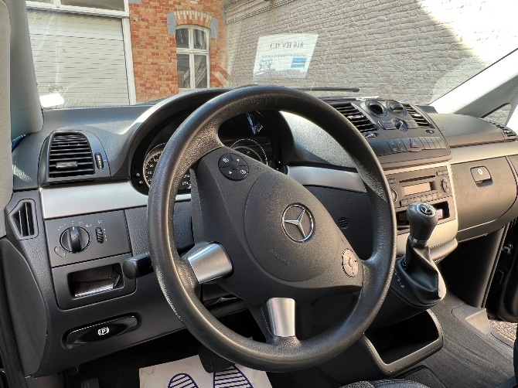 | 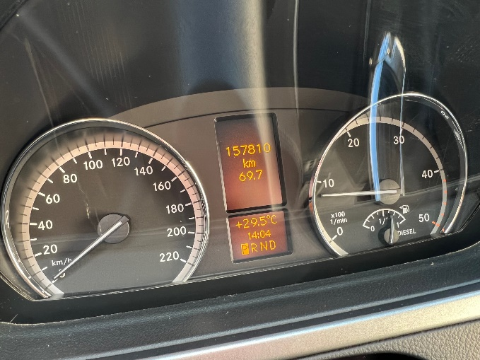
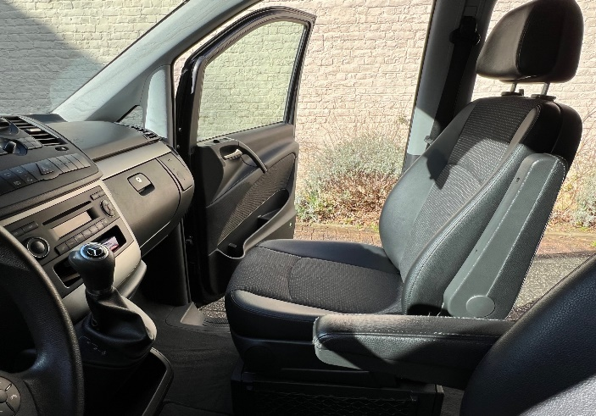 | 